INTRODUCTION
Manufacturing machine components through casting is one of the most widely used processes in engineering industries, especially for producing complex shapes economically and in large quantities. In this process, proper design of patterns and molding systems plays a crucial role in ensuring dimensional accuracy, surface finish, and defect-free production.
In this assignment, a casting component is analyzed and a suitable three-piece (cope–cheek–drag) pattern along with the corresponding molding flask is designed. The selection of pattern types, addition of necessary allowances, and proper design of cope, cheek, and drag sections are carried out to facilitate efficient molding and mass production. This work reflects practical knowledge of foundry engineering and its application in real industrial scenarios in Bangladesh.

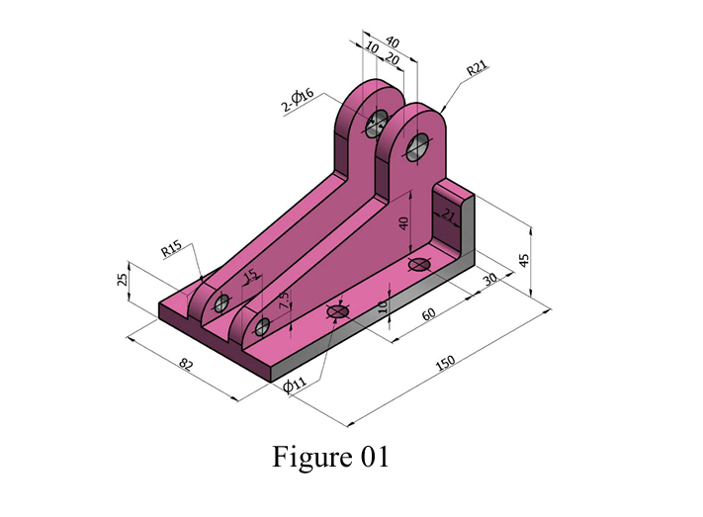
REFERENCE MACHINE PART

TYPE OF PATTERN
It is a Three-piece Pattern (Multi-piece / Split Pattern with Cheek). A three-piece pattern is selected because the component has complex geometry that cannot be properly molded using a simple split pattern.
The pattern is divided into three parts:
- Top → placed in cope
- Middle → placed in cheek
- Bottom → placed in drag
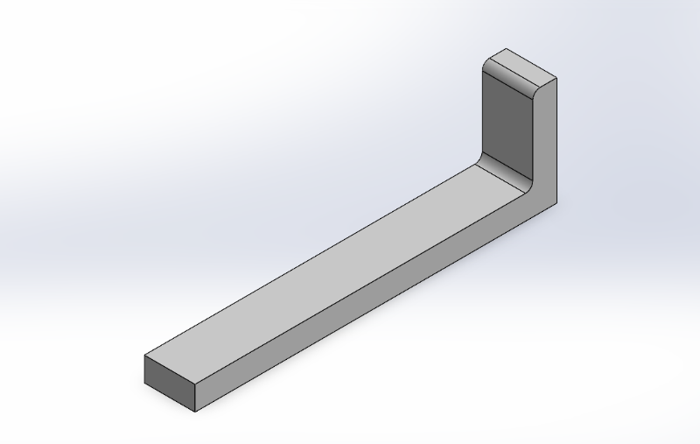
PATTERN PLACED IN COPE

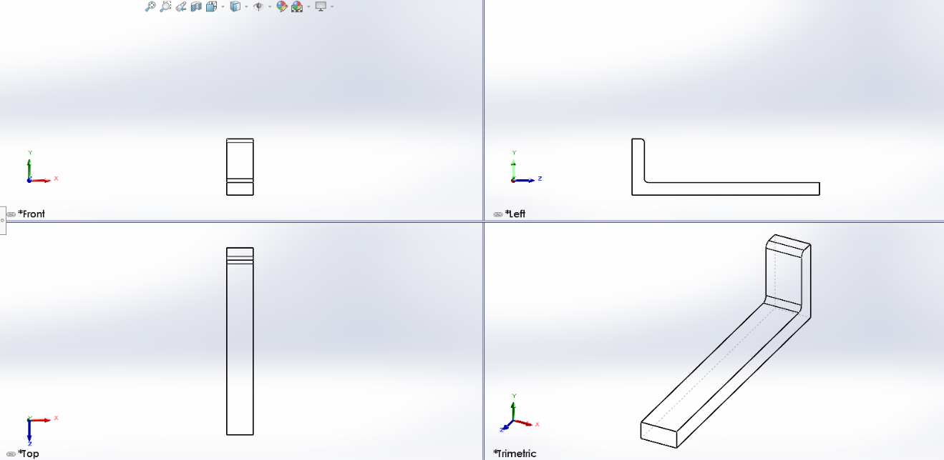
Fig: Isometric View of Top Part

Fig: Front, Top, Left and Trimatric View
PATTERN PLACED IN CHEEK
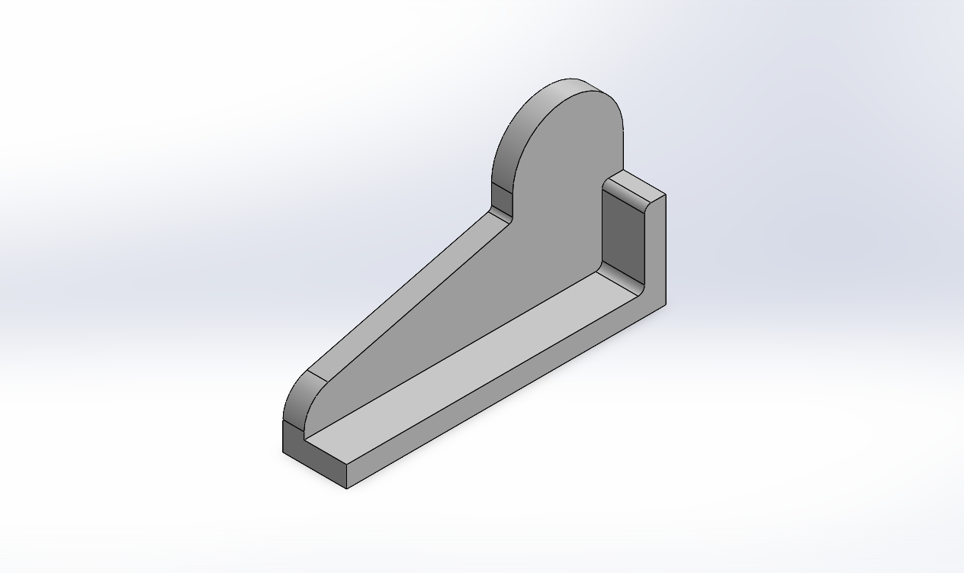

Fig: Isometric View of Middle Part
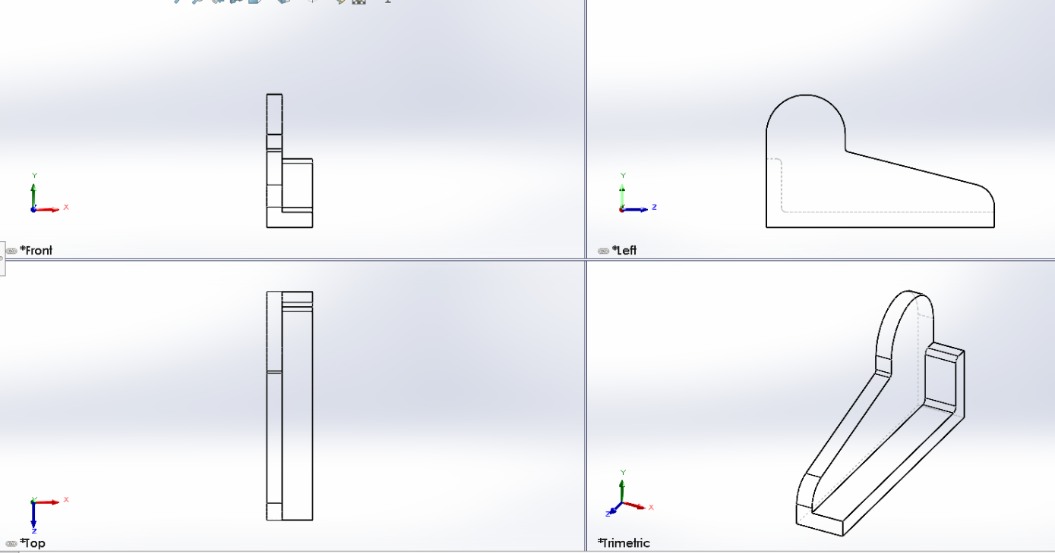

Fig: Front, Top, Left and Trimatric View
PATTERN PLACED IN DRAG

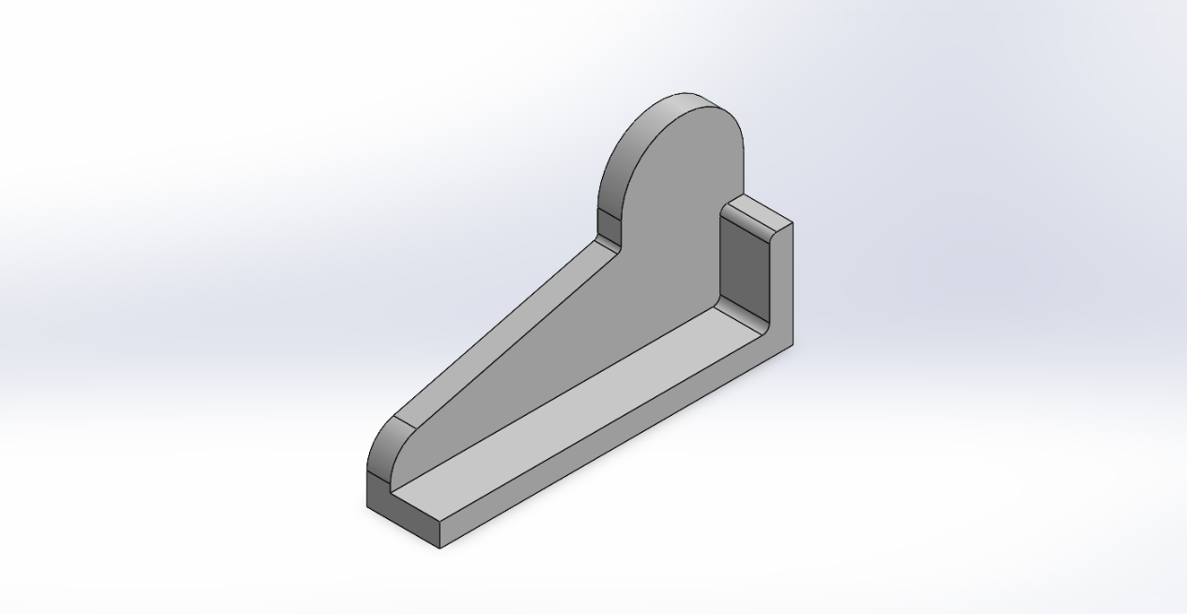

Fig: Isometric View of Bottom Part
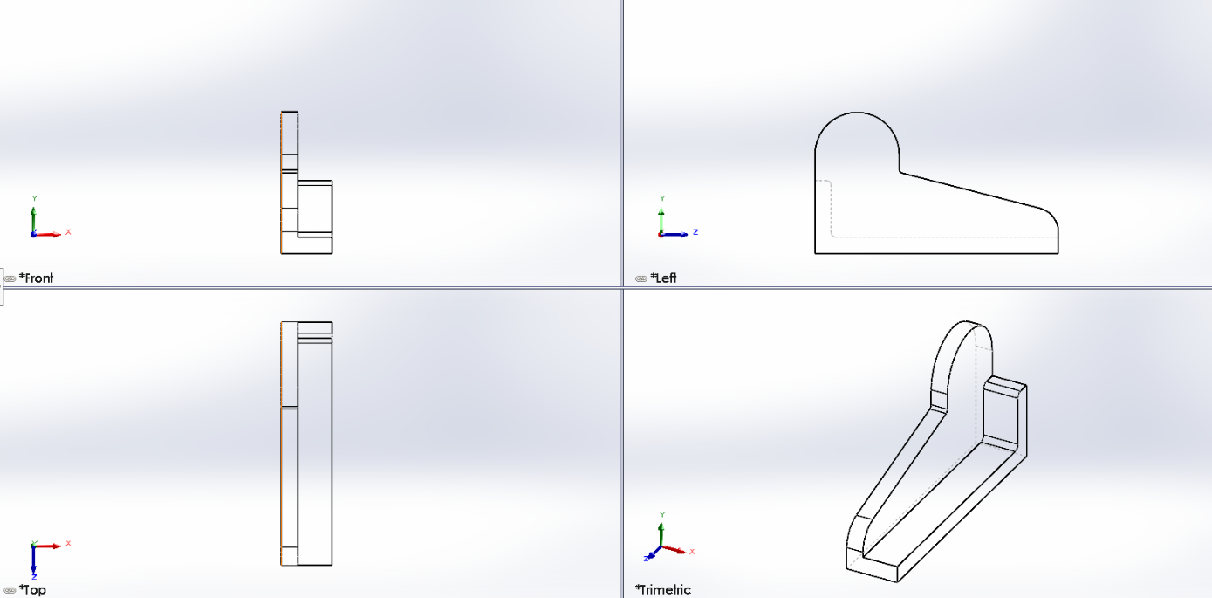

Fig: Front, Top, Left and Trimatric View
Here the pattern will need 3 flasks for the patterns and a bottom board. Those flasks and bottom board are provided bellow:
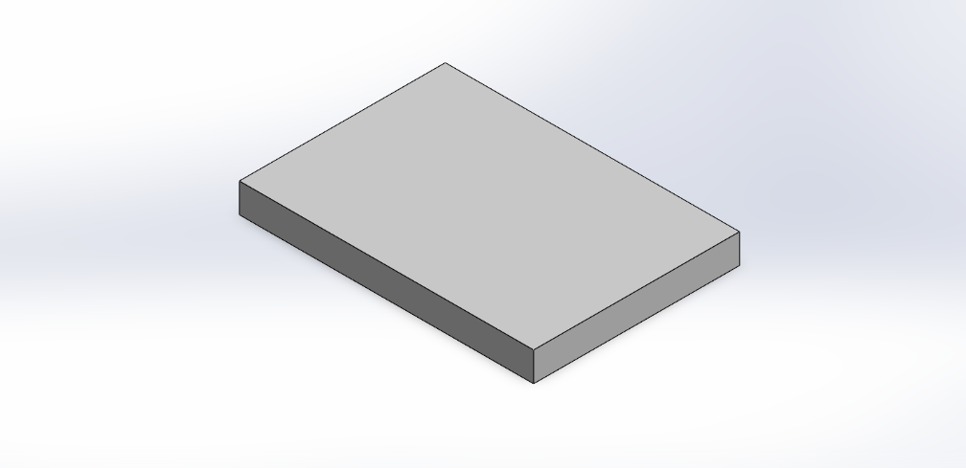
BOTTOM BOARD

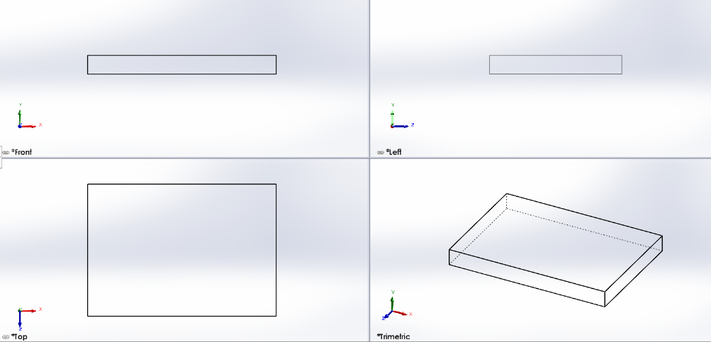
Fig: Bottom Board Isometric View

Fig: Front, Top, Left and Trimatric View
DRAG
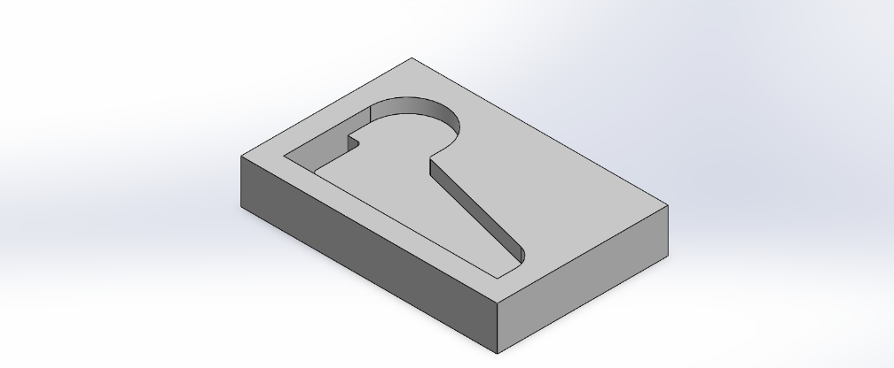

Fig: Drag Isometric View

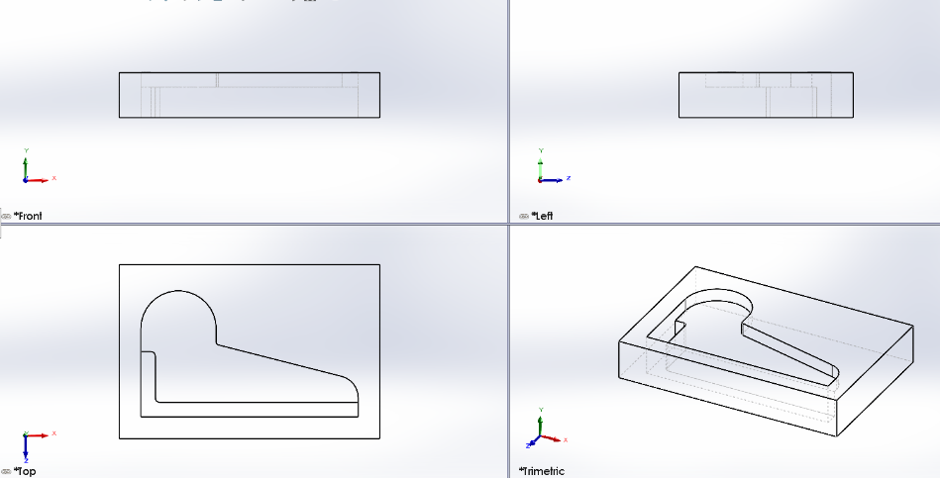

Fig: Front, Top, Left and Trimatric View
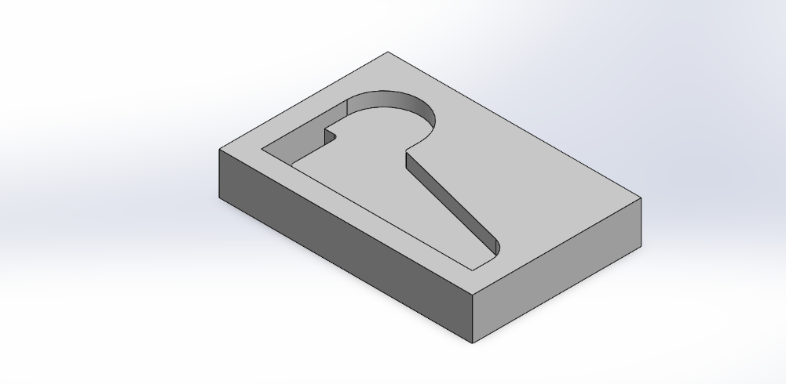
`CHEEK

Fig: Cheek Isometric View
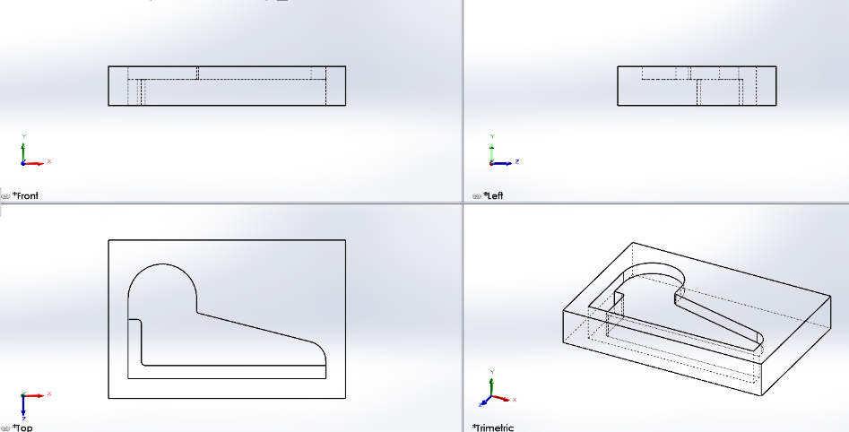

Fig: Front, Top, Left and Trimatric View

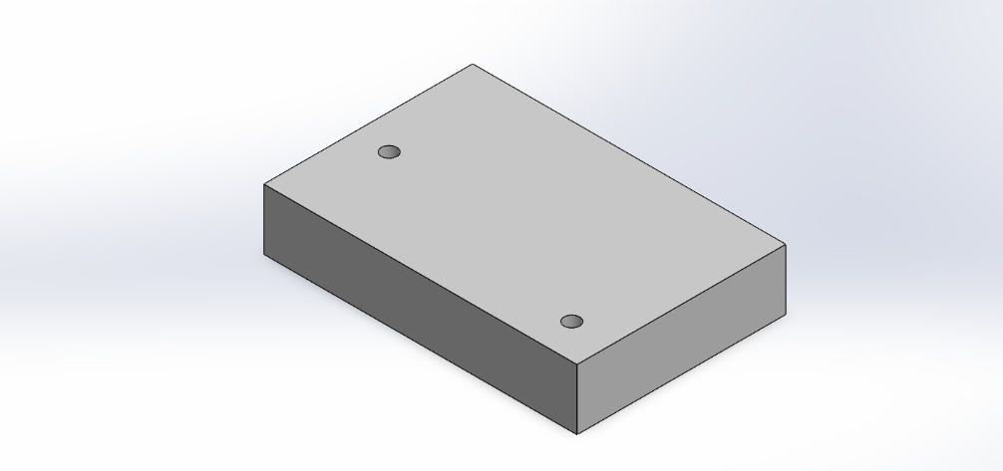
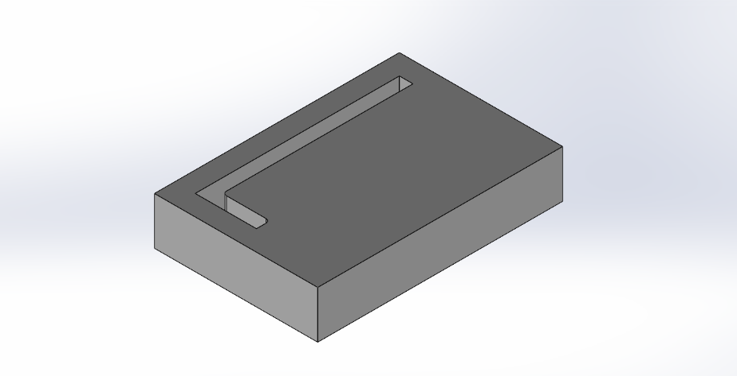
COPE

Fig: Cope Isometric View
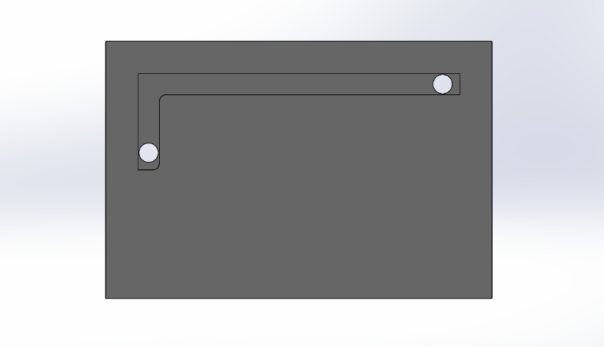

Fig: Cope Bottom View

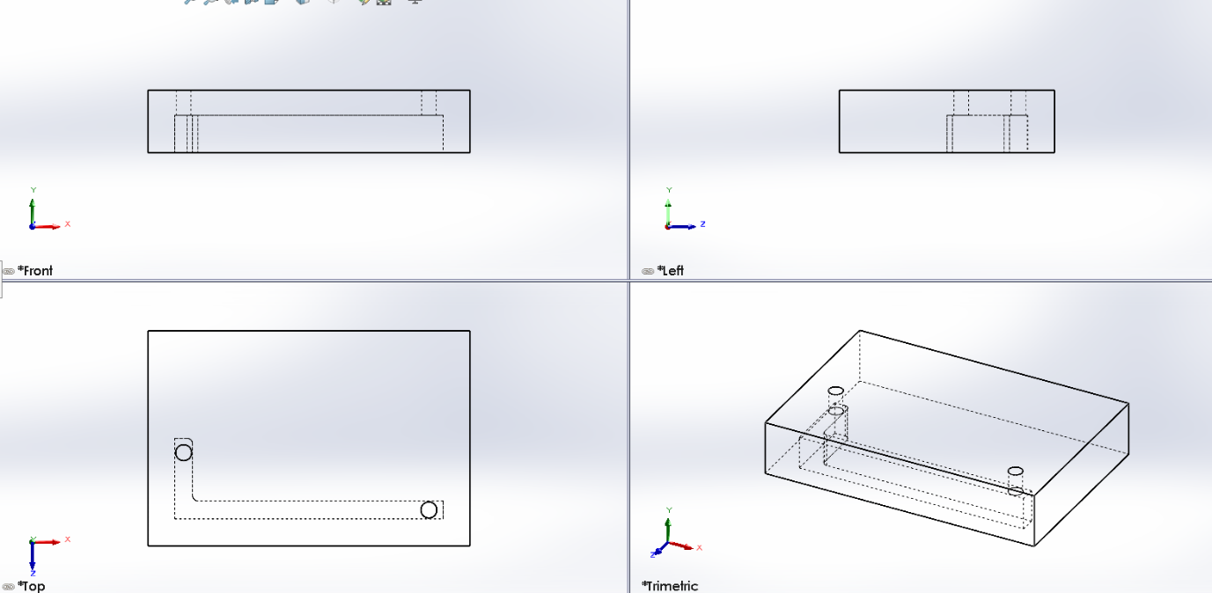

Fig: Front, Top, Left and Trimatric View
All the patterns and flasks are provided above. Now, the full assembly is given bellow:
FULL ASSEMBLY
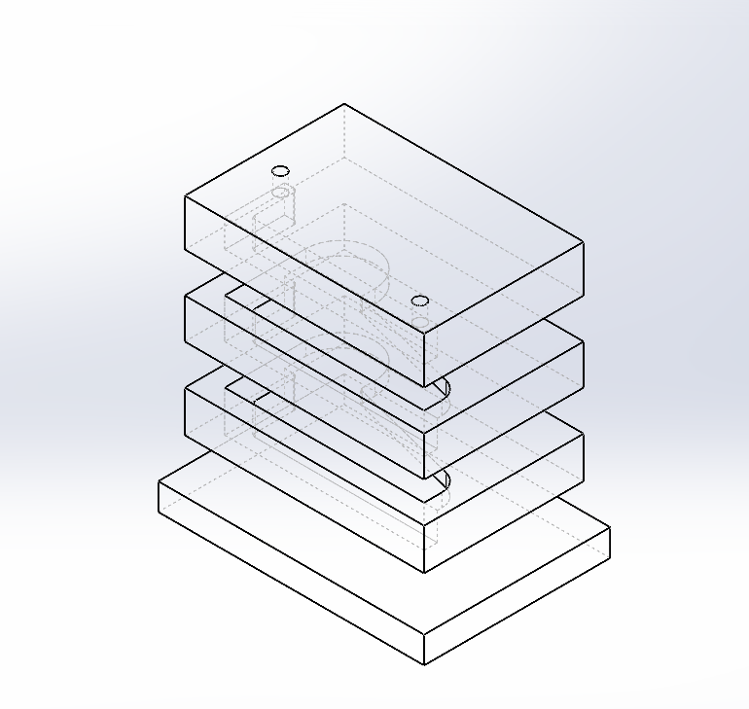

Cope
Cheek
Drag
Bottom Board

Fig: Full Assembly Isometric View
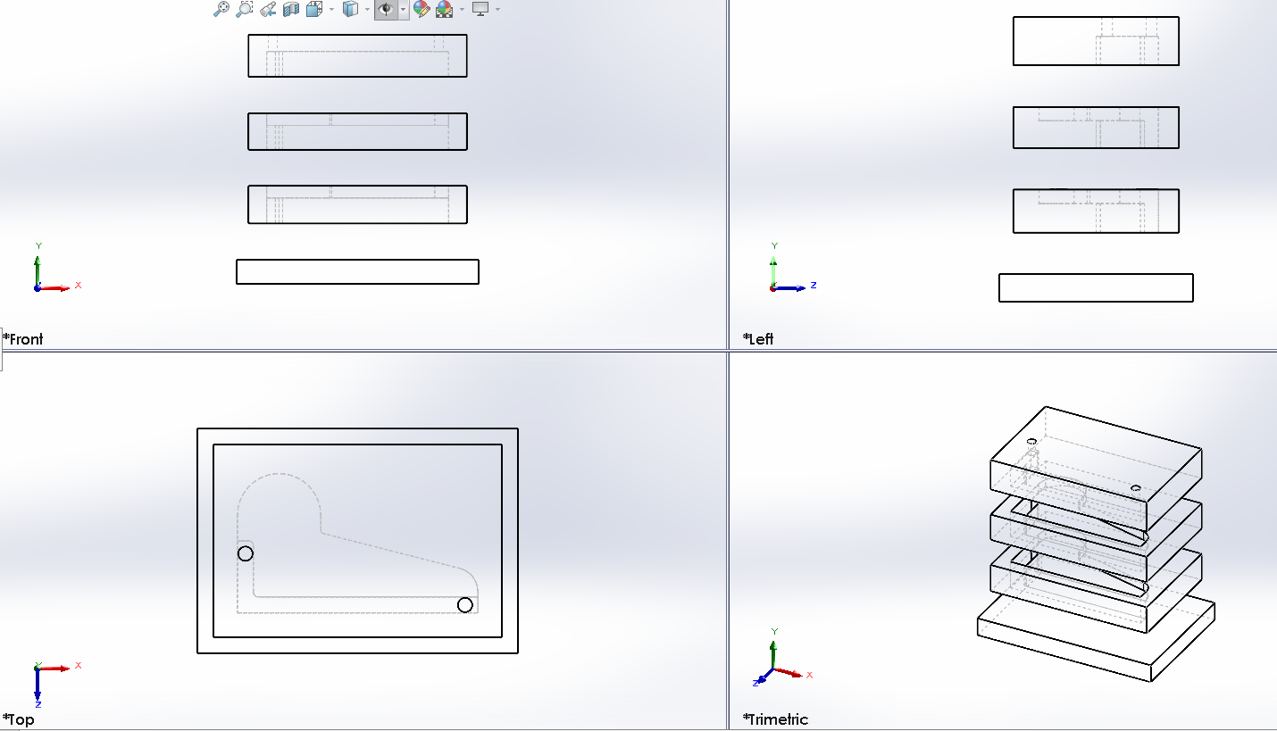

Fig: Front, Top, Left and Trimatric View

DIMENTIONING
The dimensions of the pattern are determined by adding various allowances to the actual casting dimensions. These allowances include shrinkage allowance to compensate for metal contraction during solidification, machining allowance to provide extra material for finishing operations, and draft allowance to facilitate easy withdrawal of the pattern from the mold. Proper consideration of these allowances ensures that the final casting achieves the desired size, shape, and surface quality.
So, the pattern must be slightly larger than the part in Figure 01 to allow for metal shrinkage and machining.
Feature | Part Dimension (mm) | Pattern Dimension (with ~1.5% Allowance)
Total Length | 150 mm | 152.25 mm
Total Width | 82 mm | 83.23 mm
Height of Base | 10 mm | 10.15 mm
Total Height | 45 mm (Back) / 25 mm (Front) | 45.68 mm / 25.38 mm

For a 3-piece pattern, we will need a three-part flask: Cope, Cheek, and Drag. A clearance of 40 mm is added to each side for the molding sand.
- Flask Length: 150 + 80 = 230 mm
- Flask Width: 82 + 80 = 162 mm
- Total Flask Height: Approximately 116 mm (Total height of part + sand clearance).
LEARNING OUTCOMES:
1. I learned how to identify when a component's geometry requires a multi-piece pattern to ensure it can be safely withdrawn from the sand mold without damaging the cavity.
2. I understood how to apply engineering allowances and flask sizing to prepare a theoretical design for actual production in a casting line.

CONCLUSION
In conclusion, the design of the three-piece split pattern and its corresponding molding flasks provides a robust solution for the mass production of the machine component illustrated in Fig. 01. By deconstructing the geometry into specific cope, drag, and middle segments, the design ensures that complex features can be successfully cast from raw materials in a professional industrial environment. This systematic approach bridges the gap between theoretical mechanical design and practical manufacturing, ensuring both dimensional accuracy and production efficiency.

GitHub link: https://github.com/adil-ruet/Production-Process-ME-1207-Assignment
The original files can be accessed form this link.

